MONUMENTS AND MARKS

CHRISTINE BOWEN & LEO DUFF

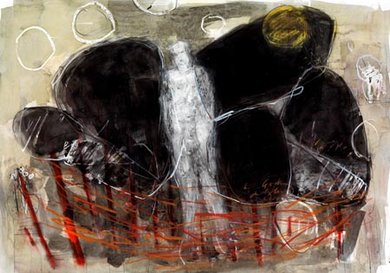


TOM CALDWELL

Chris Caldwell

Requests the pleasure of your company

at the private viewing of

MONUMENTS AND MARKS

an exhibition on archaeology by

CHRISTINE BOWEN & LEO DUFF

at 429 Lisburn Road, Belfast BT9 7EY

5:00 ~ 8:30pm

on Tuesday 14th September, 2010

Wine The exhibition will continue
Music until 2nd October, 2010
Mon & Sat 10:00 – 5:00
Tues – Fri 10.00 – 6.00

Paintings are available for purchase prior to the opening night

FRONT COVER:

LEO DUFF Fresh Flints (positive) mixed media 30” x 36”
CHRISTINE BOWEN Stone Ritual mixed media 28” x 39”

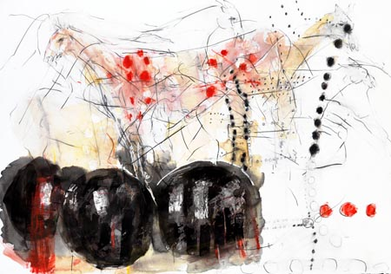
CHRISTINE BOWEN Stone Ritual mixed media 28” x 39”

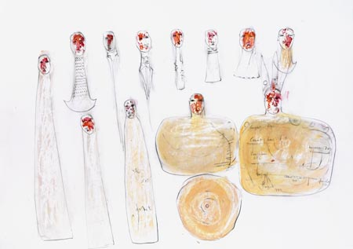
CHRISTINE BOWEN Kings Of Brega mixed media 28” x 39”

In 2007 I was asked to provide a book cover illustration for a publication by zooarchaeologist, Dr Emily Murray and Dr Finbar McCormick (both of Queens University, Belfast). This introduced me to the works of the Royal Irish Academy and archaeologist, Professor George Eogan. With him I am now into the third of five publications on Knowth, part of the Brugh na Boinne complex that includes Newgrange.

When discussing this exhibition, it seemed natural to conjoin Leo Duff’s Stonehenge and my Knowth work with a Belfast pre-history story from the Ballynahatty/Giant’s Ring site. As with the other sites, this one’s surface marks and monuments are enigmatic. The henge and the surrounding site hide more than they reveal, and so it is what’s underneath that inspires and sets my imagination/subconscious off in unlikely directions. Those unknown elements lost in time—the ceremonies, such as the sky funerals; the post-hole human diggers armed only with antler-horn tools, and all the many secrets which only the archaeologists and artists can attempt to interpret—combined with activity at the henge in more recent centuries, i.e. horseracing and fair/market activites, all cohese together in this work, with the post-holes and monument shapes as primary elements.

The artists would like to acknowledge the support of Simon Mills and the help and information generously given by Dr Emily Murray, Dr Nicky Whitehouse, Professor George Eogan, the Stonehenge Riverside Project team and Barrie Hartwell for giving of his expertise on a memorable wet afternoon in late July this year in the henge at Ballynahatty (Belfast’s Giant’s Ring) .

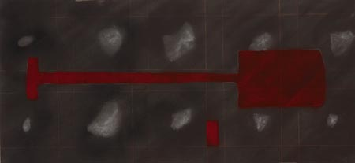
LEO DUFF Spade mixed media 22” x 47”

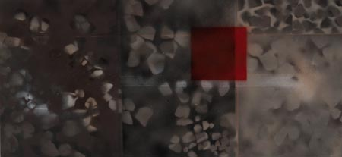
LEO DUFF Trench Flints (negative) mixed media 22” x 47”

Having worked continually as a maker of drawn images to do with A Sense of Place, of late via archaeology, Chris Caldwell's suggestion that Christine and I hold a two person exhibition came as a stimulating idea. We had both been working with archaeologists on projects to do with the recovery of objects and their interpretation on different sites. The juxtaposition of buildings, urban, rural, coastal landscapes and the environments of various forms of architecture from the vernacular to the grandiose, from pre-history to the most contemporary constructions have taken me over the world on commissioned work and to develop themes for exhibition. Being co-director of “art+archaeology” and having recently been on four residencies with the Stonehenge Riverside Project, on excavations and at Salisbury and South Wiltshire Museum, I had been thinking it was high time to return the subject matter of new work to my home turf. The perfect opportunity had arrived.

For this exhibition, I have been exploring the common tools used by archaeologists in their organised searching, and the way stone is materialised on excavation sites in the landscape surrounding Stonehenge. At the Ballynahatty henge and settlements, more commonly known as The Giants Ring in south Belfast, new work integrates memory of place with actual location. Screen printing integrated with drawing, painting, life size stencils of actual tools and spray paint reflect working methods and similarities between archaeologist and artist through process and working practice, where navigation of negative and positive spaces interact to rebuild the story of our past.

TOM CALDWELL
429 Lisburn Road, Belfast BT9 7EY
tel: 028 9066 1890 fax: 028 9068 1890
email: info@tomcaldwellgallery.com www.tomcaldwellgallery.com

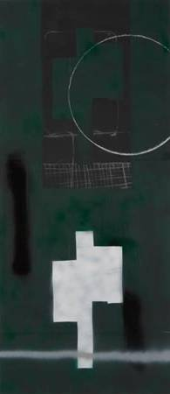
LEO DUFF Old Trench New Trench mixed media 22” x 51”

